Two Factor Authentication
To implement 2FA, in pinkvilla CMS, we have installed a plugin WP 2FA
https://wordpress.org/plugins/wp-2fa/ it’s an official wordpress plugin which supports the below mentioned features, it has the paid version which gives further more option but the the free version features are enough for our requirement
WP 2FA key plugin features and capabilities
- Free two-factor authentication (2FA) for all users
- Supports multiple 2FA methods including authenticator app TOTP, and code over email
- An API that allows you to integrate any alternative 2FA method such as WhatsApp, OTP Token, etc.
- Universal 2FA app support – generate codes from Google Authenticator, Authy, & any other 2FA app
- Supports 2FA backup codes
- Wizard-driven plugin configuration & 2FA setup – no technical knowledge required
- Use 2FA policies to enforce 2FA with a grace period or require users to instantly setup 2FA upon logging in
- No WordPress dashboard access is required for users to set up 2FA
- Fully editable email templates
- Much more

Steps to install
1) Download the plugin from the official wordpress plugin link https://wordpress.org/plugins/wp-2fa/
2) Extract the plugin to the below path
/var/www/html/git/pv-eng-cms/wp-content/plugins
3) Activate the plugin from this url https://englishcms.xynie.com/wp-admin/plugins.php
4) As we have a layer of Hertian over wordpress CMS, to get the configuration of this plugin, one more extra step is added to allow the permission for admin users.
5) Small modification in this wp-plugins/user/inc/Api/Callbacks/RoleManagerCallbacks.php to get the access
6) Once activated, configure the setting as per requirement.
We have enforced all the users to use 2FA
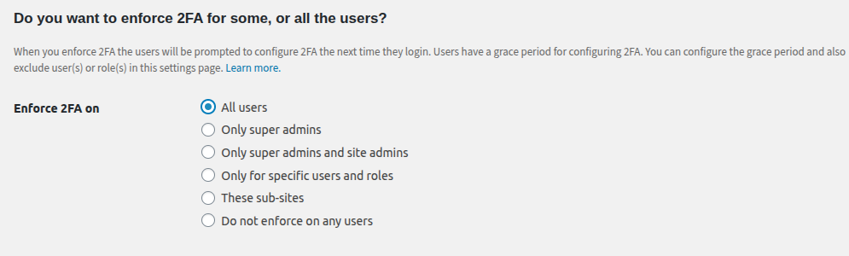

Steps for a user to activate the 2FA
2Factor Authentication on Pinkvilla CMS - Users specification

- When the 2fa is enabled, the user will see the 2fa configuration popup on next login. Their user needs to scan the QR code from the authenticator App.

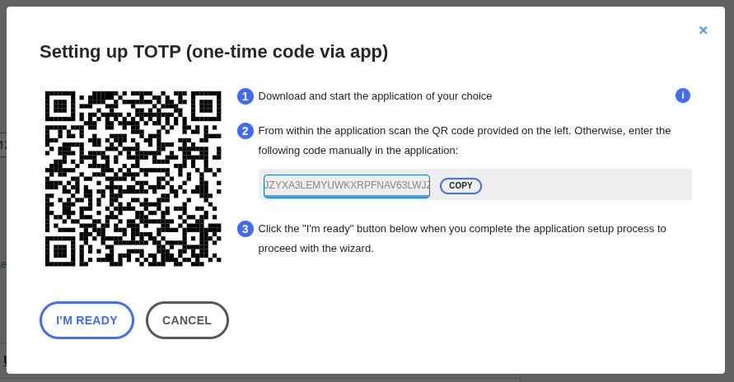

- To scan QR from Google Autheticator, install the Autheticator App in your mobile phone. Link : https://play.google.com/store/apps/details?id=com.google.android.apps.authenticator2&hl=en_IN
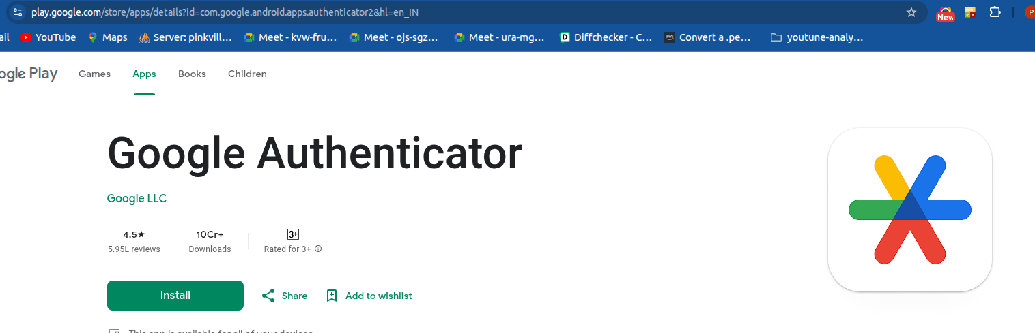

- After install, open the App, and click on + button and select “Scan a QR Code” option.

- In the next screen please scan the QR code. After scanning QR from the authenticator App, click on the button “I’M READY” to go to the next step.

- In the next prompt, you need to enter the authorization code from the Google authenticator app where you scan the QR earlier and click on button “VALIDATE & SAVE”.

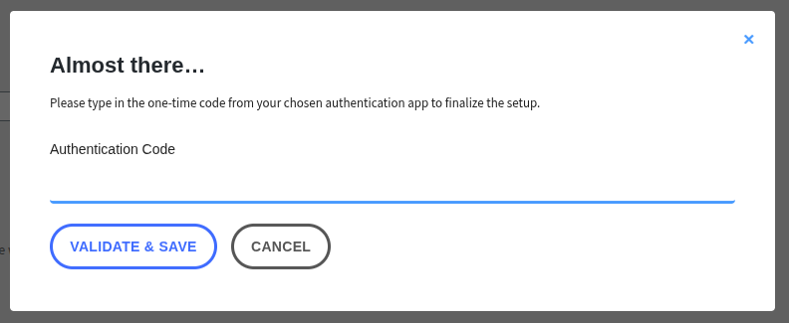

- You will be prompted to another popup which shows "Congratulations" as you have enabled the two factor authentication. For some reason, if you are not able to get google authenticator code then alternatively you can generate a list of backup codes which you can use for authentication. Else you can click on the button “I'LL GENERATE THEM LATER” and that’s it. Else it is done. It is best to use the second option generated later.

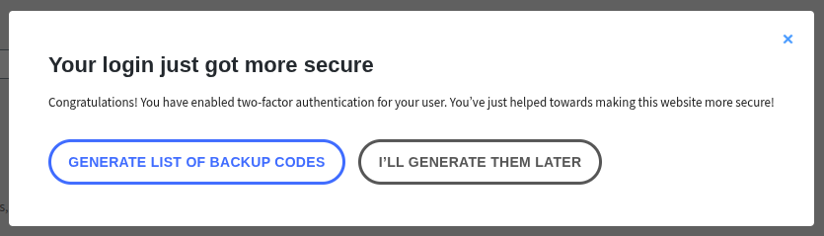

- 10 Backup codes will be generated and after the use of backup code the same can not be used for authentication again. In the next popup you will see backup code is generated having 4 buttons, you can copy and paste it somewhere to use it for authentication. Then you can close the wizard using button “I’M READY, CLOSE THE WIZARD”

